F300 Ultrasonic Information
Washer Assets: 3144 //// 3137
Machine: Ultrasonic Washer F300
Serial Number: 0613V0645 – 3144 //// 0413V0642 - 3137
Model: F-300-1812-Custom
Weight of unit as shown assembled:
Estimated weight of assembled washer: 3,500 lbs
Estimated weight of cover/ transport cover: 500 lbs

Solvent fill when empty: 62 gallons

Additional Information:
- Transport cover / cover comes off during transport
- Washer must be hooked to a chiller system / or some method of cooling for operation
- Cover and tanks would be crated individually when transported (disassembly and reassembly when received to destination)
Dimensional information highlighted below.
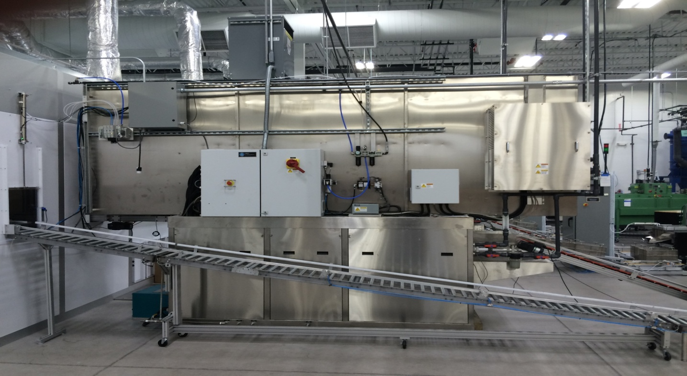
116 inches in height
147 inches include washer and load /unload tables
166 inches for cover / transport
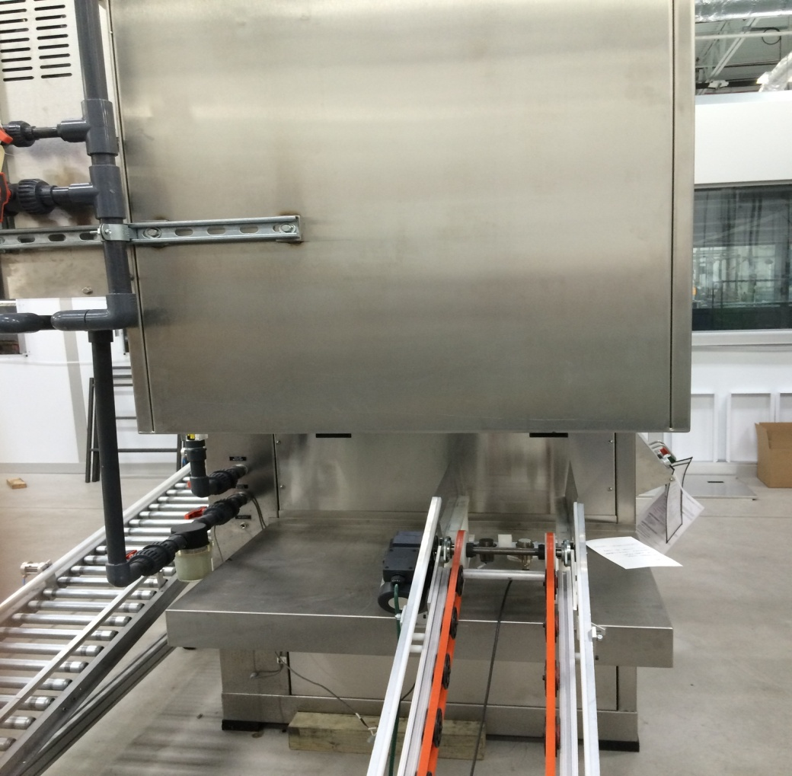
46 inches wide

